NAME : PATOLE PRATIK ARUN

DIV : D ROLL NO : 6390

SUBJECT : CORE JAVA

PROJECT NAME : ONLINE EXAMINATION TEST

INTRODUCTION :

Online Examination System project could be a web portal which is developed or implemented in java domain or platform. This project is helpful for students to practice different mock examinations from this site. In current generation lots of the examinations like GRE, CAT, and MAT…etc is conducted through online system. This project will help students to get practiced to online examination method by taking mock tests from this web portal. Online Examination System portal is implemented in 2 modules student examination module and examination admin module. Admin module will add multiple courses under different branches so students can easily know about test details. Student examination module students ought to register with application and choose interested courses and participate in the online test.

**Project Modules**

1-Administrator module

 2-Student module

 After feeding the desired info(s) to the Login window the system checks user style of the corresponding user ID.

 If it is admin then it’ll settle for administrator login & provides Administrator view else Student view.

## ****Major Operations****

The following are the major operations of this application.

* Administrator input or enter password to enter into system
* Adding new course
* Adding new batch
* Adding students to batch
* Adding questions of courses
* Listing examination details
* Listing questions, bathes etc.
* Changing of password

**Major Operations**

The following are the major operations of this application.

* Administrator input or enter password to enter into system
* Adding new course
* Adding new batch
* Adding students to batch
* Adding questions of courses
* Listing examination details
* Listing questions, bathes etc.
* Changing of password

CODE : import java.awt.*;

import java.awt.event.*;

import javax.swing.*;

class OnlineTest extends JFrame implements ActionListener

{

JLabel l;

JRadioButton jb[]=new JRadioButton[5];

JButton b1,b2;

ButtonGroup bg;

int count=0,current=0,x=1,y=1,now=0;

int m[]=new int[10];

OnlineTest(String s)

{

super(s);

l=new JLabel();

add(l);

bg=new ButtonGroup();

for(int i=0;i<5;i++)

{

jb[i]=new JRadioButton();

add(jb[i]);

bg.add(jb[i]);

}

b1=new JButton("Next");

b2=new JButton("Bookmark");

b1.addActionListener(this);

b2.addActionListener(this);

add(b1);add(b2);

set();

l.setBounds(30,40,450,20);

jb[0].setBounds(50,80,100,20);

jb[1].setBounds(50,110,100,20);

jb[2].setBounds(50,140,100,20);

jb[3].setBounds(50,170,100,20);

b1.setBounds(100,240,100,30);

b2.setBounds(270,240,100,30);

setDefaultCloseOperation(JFrame.EXIT_ON_CLOSE);

setLayout(null);

setLocation(250,100);

setVisible(true);

setSize(600,350);

}

public void actionPerformed(ActionEvent e)

{

if(e.getSource()==b1)

{

if(check())

count=count+1;

current++;

set();

if(current==9)

{

b1.setEnabled(false);

b2.setText("Result");

}

}

if(e.getActionCommand().equals("Bookmark"))

{

JButton bk=new JButton("Bookmark"+x);

bk.setBounds(480,20+30*x,100,30);

add(bk);

bk.addActionListener(this);

m[x]=current;

x++;

current++;

set();

if(current==9)

b2.setText("Result");

setVisible(false);

setVisible(true);

}

for(int i=0,y=1;i<x;i++,y++)

{

if(e.getActionCommand().equals("Bookmark"+y))

{

if(check())

count=count+1;

now=current;

current=m[y];

set();

((JButton)e.getSource()).setEnabled(false);

current=now;

}

}

if(e.getActionCommand().equals("Result"))

{

if(check())

count=count+1;

current++;

//System.out.println("correct ans="+count);

JOptionPane.showMessageDialog(this,"correct ans="+count);

System.exit(0);

}

}

void set()

{

jb[4].setSelected(true);

if(current==0)

{

l.setText("Que1: Which one among these is not a primitive datatype?");

jb[0].setText("int");jb[1].setText("Float");jb[2].setText("boolean");jb[3].setText("char");

}

if(current==1)

{

l.setText("Que2: Which class is available to all the class automatically?");

jb[0].setText("Swing");jb[1].setText("Applet");jb[2].setText("Object");jb[3].setText("ActionEvent");

}

if(current==2)

{

l.setText("Que3: Which package is directly available to our class without importing it?");

jb[0].setText("swing");jb[1].setText("applet");jb[2].setText("net");jb[3].setText("lang");

}

if(current==3)

{

l.setText("Que4: String class is defined in which package?");

jb[0].setText("lang");jb[1].setText("Swing");jb[2].setText("Applet");jb[3].setText("awt");

}

if(current==4)

{

l.setText("Que5: Which institute is best for java coaching?");

jb[0].setText("Utek");jb[1].setText("Aptech");jb[2].setText("SSS IT");jb[3].setText("jtek");

}

if(current==5)

{

l.setText("Que6: Which one among these is not a keyword?");

jb[0].setText("class");jb[1].setText("int");jb[2].setText("get");jb[3].setText("if");

}

if(current==6)

{

l.setText("Que7: Which one among these is not a class? ");

jb[0].setText("Swing");jb[1].setText("Actionperformed");jb[2].setText("ActionEvent");

jb[3].setText("Button");

}

if(current==7)

{

l.setText("Que8: which one among these is not a function of Object class?");

jb[0].setText("toString");jb[1].setText("finalize");jb[2].setText("equals");

jb[3].setText("getDocumentBase");

}

if(current==8)

{

l.setText("Que9: which function is not present in Applet class?");

jb[0].setText("init");jb[1].setText("main");jb[2].setText("start");jb[3].setText("destroy");

}

if(current==9)

{

l.setText("Que10: Which one among these is not a valid component?");

jb[0].setText("JButton");jb[1].setText("JList");jb[2].setText("JButtonGroup");

jb[3].setText("JTextArea");

}

l.setBounds(30,40,450,20);

for(int i=0,j=0;i<=90;i+=30,j++)

jb[j].setBounds(50,80+i,200,20);

}

boolean check()

{

if(current==0)

return(jb[1].isSelected());

if(current==1)

return(jb[2].isSelected());

if(current==2)

return(jb[3].isSelected());

if(current==3)

return(jb[0].isSelected());

if(current==4)

return(jb[2].isSelected());

if(current==5)

return(jb[2].isSelected());

if(current==6)

return(jb[1].isSelected());

if(current==7)

return(jb[3].isSelected());

if(current==8)

return(jb[1].isSelected());

if(current==9)

return(jb[2].isSelected());

return false;

}

public static void main(String s[])

{

new OnlineTest("Online Test Of Java");

}

}

1 . 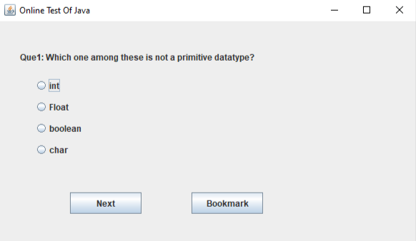

2 . 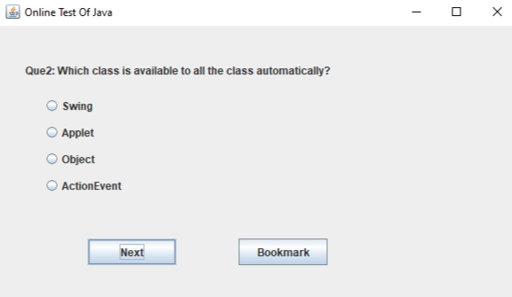

3

3 . 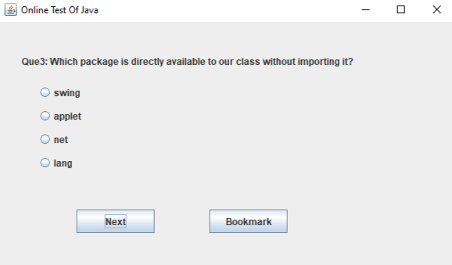

4 . 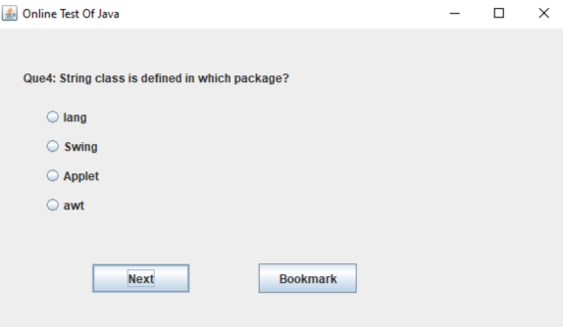

5 . 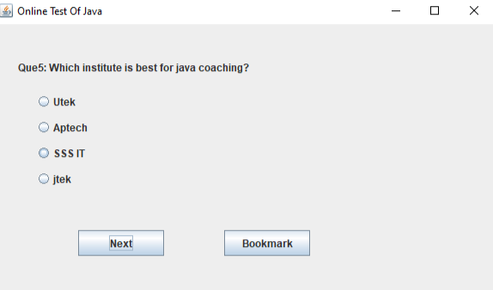

6. 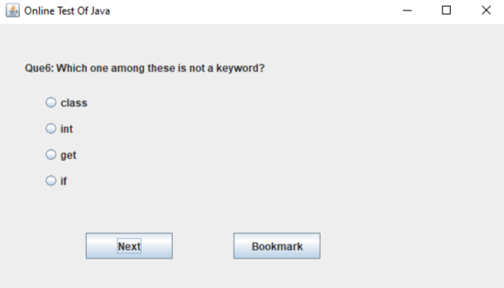

7. 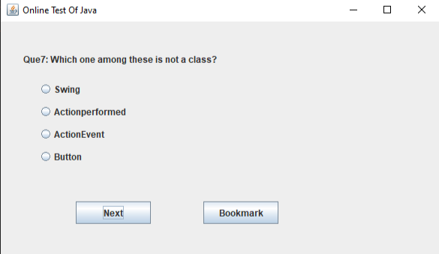

8. 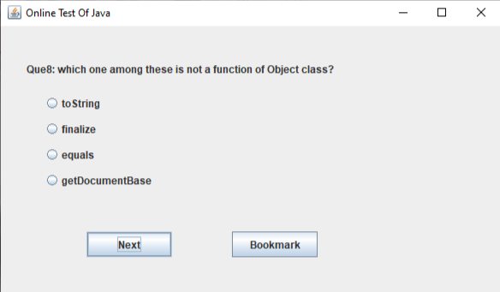

9. 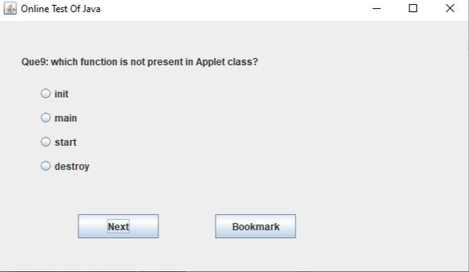

10. 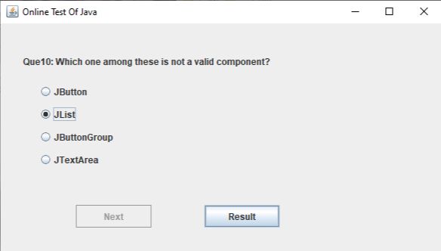

11. 